Synchronizing SQL Server Logins in an Always On Availability Group
https://maq.guru/synchronizing-sql-server-logins-in-an-always-on-availability-group/
Always On Availability Group is not a new feature, released in SQL Server 2012. Always On Availability Group “claims” to provide a high availability and disaster recovery solution. That is not 100% correct, as it does not provide HADR to many system objects e.g. SQL Agent jobs, SQL Server logins, Linked Servers etc.
If you forget to create SQL Server logins or update passwords/permissions on secondary replicas and a failover occurs users/apps will not have access to the “new” primary replica.
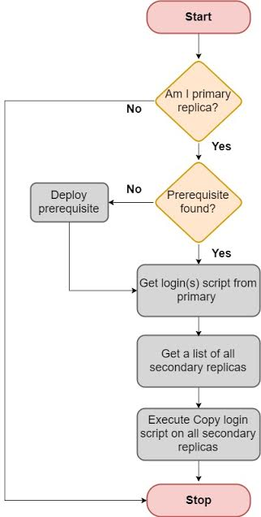
One of our clients had the same issue. I have implemented a solution using the power of PowerShell to resolve it.
In this solution, a SQL Agent job executes a PowerShell script on the Primary replica that takes care of new logins and password/permission change. Although, the job exists on all nodes but it is smart enough to know which node it should execute on.

As soon as the new login creation or password/permission change event occurs, the script replicates it on all secondary nodes.

Download the below script and extract it. The zipped script is a powershell script.


Limitations: The script will not copy existing logins unless you make a change to them e.g. password change, grant/revoke privileges etc.
Prerequisites:
“sp_hexadecimal” should be deployed on all cluster nodes.
Remember to remove/comment out “Write-Host” statements if running as SQL Agent Job
Script will not do anything if you did not modify or created a login
References: TSQL script based upon “sp_hexadecimal” by Microsoft and TSQL to get the “create login” script based upon Claire Hsu

